Name-Ujjawal Mandhani
Batch-F6
Enroll No.-9918103237
ISL Week 2 C

Question 1:Implement DES algorithm.
#include <bits/stdc++.h>
using namespace std;
string hex2bin(string s)
{
unordered_map<char, string> mp;
mp['0'] = "0000";
mp['1'] = "0001";
mp['2'] = "0010";
mp['3'] = "0011";
mp['4'] = "0100";
mp['5'] = "0101";
mp['6'] = "0110";
mp['7'] = "0111";
mp['8'] = "1000";
mp['9'] = "1001";
mp['A'] = "1010";
mp['B'] = "1011";
mp['C'] = "1100";
mp['D'] = "1101";
mp['E'] = "1110";
mp['F'] = "1111";
string bin = "";
for (int i = 0; i < s.size(); i++)
{
bin += mp[s[i]];
}
return bin;
}
string bin2hex(string s)
{
unordered_map<string, string> mp;
mp["0000"] = "0";
mp["0001"] = "1";
mp["0010"] = "2";
mp["0011"] = "3";
mp["0100"] = "4";
mp["0101"] = "5";
mp["0110"] = "6";
mp["0111"] = "7";
mp["1000"] = "8";
mp["1001"] = "9";
mp["1010"] = "A";
mp["1011"] = "B";
mp["1100"] = "C";
mp["1101"] = "D";
mp["1110"] = "E";
mp["1111"] = "F";
string hex = "";
for (int i = 0; i < s.length(); i += 4)
{
string ch = "";
ch += s[i];
ch += s[i + 1];
ch += s[i + 2];
ch += s[i + 3];
hex += mp[ch];
}
return hex;
}

string permute(string k, int *arr, int n)
{
string per = "";
for (int i = 0; i < n; i++)
{
per += k[arr[i] - 1];
}
return per;
}

string shift_left(string k, int shifts)
{
string s = "";
for (int i = 0; i < shifts; i++)
{
for (int j = 1; j < 28; j++)
{
s += k[j];
}
s += k[0];
k = s;
s = "";
}
return k;
}

string xor_(string a, string b)
{
string ans = "";
for (int i = 0; i < a.size(); i++)
{
if (a[i] == b[i])
{
ans += "0";
}
else
{
ans += "1";
}
}
return ans;
}
string encrypt(string pt, vector<string> rkb, vector<string> rk)
{
pt = hex2bin(pt);
int initial_perm[64] = {58, 50, 42, 34, 26, 18, 10, 2,
60, 52, 44, 36, 28, 20, 12, 4,
62, 54, 46, 38, 30, 22, 14, 6,
64, 56, 48, 40, 32, 24, 16, 8,
57, 49, 41, 33, 25, 17, 9, 1,
59, 51, 43, 35, 27, 19, 11, 3,
61, 53, 45, 37, 29, 21, 13, 5,
63, 55, 47, 39, 31, 23, 15, 7};
pt = permute(pt, initial_perm, 64);
cout << "After initial permutation: " << bin2hex(pt) << endl;

string left = pt.substr(0, 32);
string right = pt.substr(32, 32);
cout << "After splitting: L0=" << bin2hex(left)
<< " R0=" << bin2hex(right) << endl;
int exp_d[48] = {32, 1, 2, 3, 4, 5, 4, 5,
6, 7, 8, 9, 8, 9, 10, 11,
12, 13, 12, 13, 14, 15, 16, 17,
16, 17, 18, 19, 20, 21, 20, 21,
22, 23, 24, 25, 24, 25, 26, 27,
28, 29, 28, 29, 30, 31, 32, 1};

int s[8][4][16] = {{14, 4, 13, 1, 2, 15, 11, 8, 3, 10, 6, 12, 5, 9, 0, 7,
0, 15, 7, 4, 14, 2, 13, 1, 10, 6, 12, 11, 9, 5, 3, 8,
4, 1, 14, 8, 13, 6, 2, 11, 15, 12, 9, 7, 3, 10, 5, 0,
15, 12, 8, 2, 4, 9, 1, 7, 5, 11, 3, 14, 10, 0, 6, 13},
{15, 1, 8, 14, 6, 11, 3, 4, 9, 7, 2, 13, 12, 0, 5, 10,
3, 13, 4, 7, 15, 2, 8, 14, 12, 0, 1, 10, 6, 9, 11, 5,
0, 14, 7, 11, 10, 4, 13, 1, 5, 8, 12, 6, 9, 3, 2, 15,
13, 8, 10, 1, 3, 15, 4, 2, 11, 6, 7, 12, 0, 5, 14, 9},

{10, 0, 9, 14, 6, 3, 15, 5, 1, 13, 12, 7, 11, 4, 2, 8,
13, 7, 0, 9, 3, 4, 6, 10, 2, 8, 5, 14, 12, 11, 15, 1,
13, 6, 4, 9, 8, 15, 3, 0, 11, 1, 2, 12, 5, 10, 14, 7,
1, 10, 13, 0, 6, 9, 8, 7, 4, 15, 14, 3, 11, 5, 2, 12},
{7, 13, 14, 3, 0, 6, 9, 10, 1, 2, 8, 5, 11, 12, 4, 15,
13, 8, 11, 5, 6, 15, 0, 3, 4, 7, 2, 12, 1, 10, 14, 9,
10, 6, 9, 0, 12, 11, 7, 13, 15, 1, 3, 14, 5, 2, 8, 4,
3, 15, 0, 6, 10, 1, 13, 8, 9, 4, 5, 11, 12, 7, 2, 14},
{2, 12, 4, 1, 7, 10, 11, 6, 8, 5, 3, 15, 13, 0, 14, 9,
14, 11, 2, 12, 4, 7, 13, 1, 5, 0, 15, 10, 3, 9, 8, 6,
4, 2, 1, 11, 10, 13, 7, 8, 15, 9, 12, 5, 6, 3, 0, 14,
11, 8, 12, 7, 1, 14, 2, 13, 6, 15, 0, 9, 10, 4, 5, 3},
{12, 1, 10, 15, 9, 2, 6, 8, 0, 13, 3, 4, 14, 7, 5, 11,
10, 15, 4, 2, 7, 12, 9, 5, 6, 1, 13, 14, 0, 11, 3, 8,
9, 14, 15, 5, 2, 8, 12, 3, 7, 0, 4, 10, 1, 13, 11, 6,
4, 3, 2, 12, 9, 5, 15, 10, 11, 14, 1, 7, 6, 0, 8, 13},
{4, 11, 2, 14, 15, 0, 8, 13, 3, 12, 9, 7, 5, 10, 6, 1,
13, 0, 11, 7, 4, 9, 1, 10, 14, 3, 5, 12, 2, 15, 8, 6,
1, 4, 11, 13, 12, 3, 7, 14, 10, 15, 6, 8, 0, 5, 9, 2,
6, 11, 13, 8, 1, 4, 10, 7, 9, 5, 0, 15, 14, 2, 3, 12},
{13, 2, 8, 4, 6, 15, 11, 1, 10, 9, 3, 14, 5, 0, 12, 7,
1, 15, 13, 8, 10, 3, 7, 4, 12, 5, 6, 11, 0, 14, 9, 2,
7, 11, 4, 1, 9, 12, 14, 2, 0, 6, 10, 13, 15, 3, 5, 8,
2, 1, 14, 7, 4, 10, 8, 13, 15, 12, 9, 0, 3, 5, 6, 11}};

int per[32] = {16, 7, 20, 21,
29, 12, 28, 17,
1, 15, 23, 26,
5, 18, 31, 10,
2, 8, 24, 14,
32, 27, 3, 9,
19, 13, 30, 6,
22, 11, 4, 25};

cout << endl;
for (int i = 0; i < 16; i++)
{
string right_expanded = permute(right, exp_d, 48);
string x = xor_(rkb[i], right_expanded);
string op = "";
for (int i = 0; i < 8; i++)
{
int row = 2 * int(x[i * 6] - '0') + int(x[i * 6 + 5] - '0');
int col = 8 * int(x[i * 6 + 1] - '0') + 4 * int(x[i * 6 + 2] - '0') + 2 * int(x[i * 6 + 3] - '0') + int(x[i * 6 + 4] - '0');
int val = s[i][row][col];
op += char(val / 8 + '0');
val = val % 8;
op += char(val / 4 + '0');
val = val % 4;
op += char(val / 2 + '0');
val = val % 2;
op += char(val + '0');
}
op = permute(op, per, 32);
x = xor_(op, left);

left = x;
if (i != 15)
{
swap(left, right);
}
cout << "Round " << i + 1 << " " << bin2hex(left) << " "
<< bin2hex(right) << " " << rk[i] << endl;
}
string combine = left + right;
int final_perm[64] = {40, 8, 48, 16, 56, 24, 64, 32,
39, 7, 47, 15, 55, 23, 63, 31,
38, 6, 46, 14, 54, 22, 62, 30,
37, 5, 45, 13, 53, 21, 61, 29,
36, 4, 44, 12, 52, 20, 60, 28,
35, 3, 43, 11, 51, 19, 59, 27,
34, 2, 42, 10, 50, 18, 58, 26,
33, 1, 41, 9, 49, 17, 57, 25};

string cipher = bin2hex(permute(combine, final_perm, 64));
return cipher;
}
int main()
{
string pt, key;
cout << "Enter plain text(in hexadecimal): ";
cin >> pt;
cout << "Enter key(in hexadecimal): ";
cin >> key;
key = hex2bin(key);
int keyp[56] = {57, 49, 41, 33, 25, 17, 9,
1, 58, 50, 42, 34, 26, 18,
10, 2, 59, 51, 43, 35, 27,
19, 11, 3, 60, 52, 44, 36,
63, 55, 47, 39, 31, 23, 15,
7, 62, 54, 46, 38, 30, 22,
14, 6, 61, 53, 45, 37, 29,
21, 13, 5, 28, 20, 12, 4};

key = permute(key, keyp, 56);
int shift_table[16] = {1, 1, 2, 2,
2, 2, 2, 2,
1, 2, 2, 2,
2, 2, 2, 1};
int key_comp[48] = {14, 17, 11, 24, 1, 5,
3, 28, 15, 6, 21, 10,
23, 19, 12, 4, 26, 8,
16, 7, 27, 20, 13, 2,
41, 52, 31, 37, 47, 55,
30, 40, 51, 45, 33, 48,
44, 49, 39, 56, 34, 53,
46, 42, 50, 36, 29, 32};

string left = key.substr(0, 28);
string right = key.substr(28, 28);

vector<string> rkb;
vector<string> rk;
for (int i = 0; i < 16; i++)
{
left = shift_left(left, shift_table[i]);
right = shift_left(right, shift_table[i]);
string combine = left + right;
string RoundKey = permute(combine, key_comp, 48);

rkb.push_back(RoundKey);
rk.push_back(bin2hex(RoundKey));
}

cout << "\nEncryption:\n\n";
string cipher = encrypt(pt, rkb, rk);
cout << "\nCipher Text: " << cipher << endl;

cout << "\nDecryption\n\n";
reverse(rkb.begin(), rkb.end());
reverse(rk.begin(), rk.end());
string text = encrypt(cipher, rkb, rk);
cout << "\nPlain Text: " << text << endl;
}

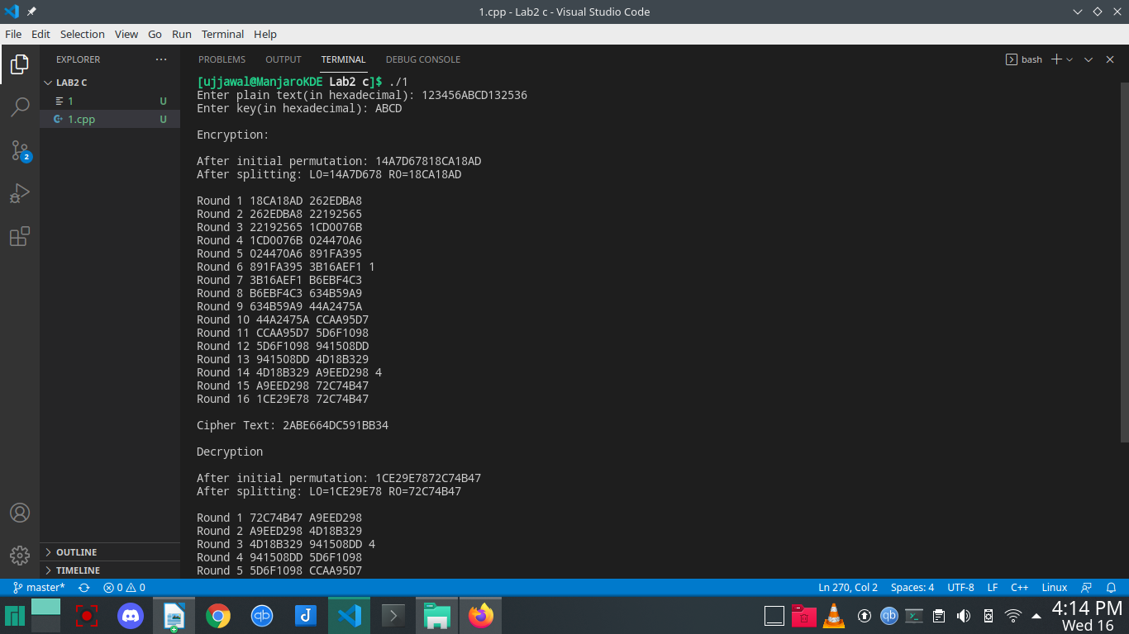
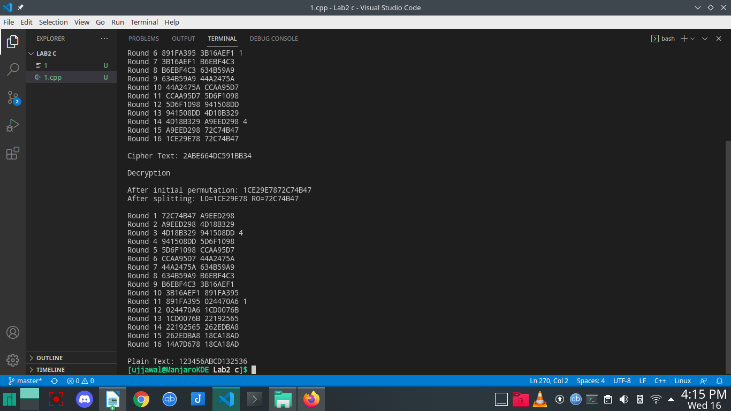
Question 2:2: The Diffie-Hellman algorithm is being used to establish a shared secret that can be used for secret communications while exchanging data over a public network using the elliptic curve to generate points and get the secret key using the parameters.

• For the sake of simplicity and practical implementation of the algorithm, we will consider
only 4 variables one prime P and G (a primitive root of P) and two private values a and b.

• P and G are both publicly available numbers. Users (say Alice and Bob) pick private values a
and b and they generate a key and exchange it publicly, the opposite person received the key
and from that generates a secret key after which they have the same secret key to encrypt.

#include <stdio.h>
#include <math.h>

long long int power(long long int a, long long int b, long long int P)
{
if (b == 1)
return a;

else
return (((long long int)pow(a, b)) % P);
}
int main()
{
long long int P, G, x, a, y, b, ka, kb;
scanf("%lld", &P);
scanf("%lld", &G);
scanf("%lld", &a);
scanf("%lld", &b);
printf("The value of P : %lld\n", P);
printf("The value of G : %lld\n\n", G);
printf("The private key a for Alice : %lld\n", a);
x = power(G, a, P);
printf("The private key b for Bob : %lld\n\n", b);
y = power(G, b, P);
ka = power(y, a, P);
kb = power(x, b, P);

printf("Secret key for the Alice is : %lld\n", ka);
printf("Secret Key for the Bob is : %lld\n", kb);

return 0;
}

